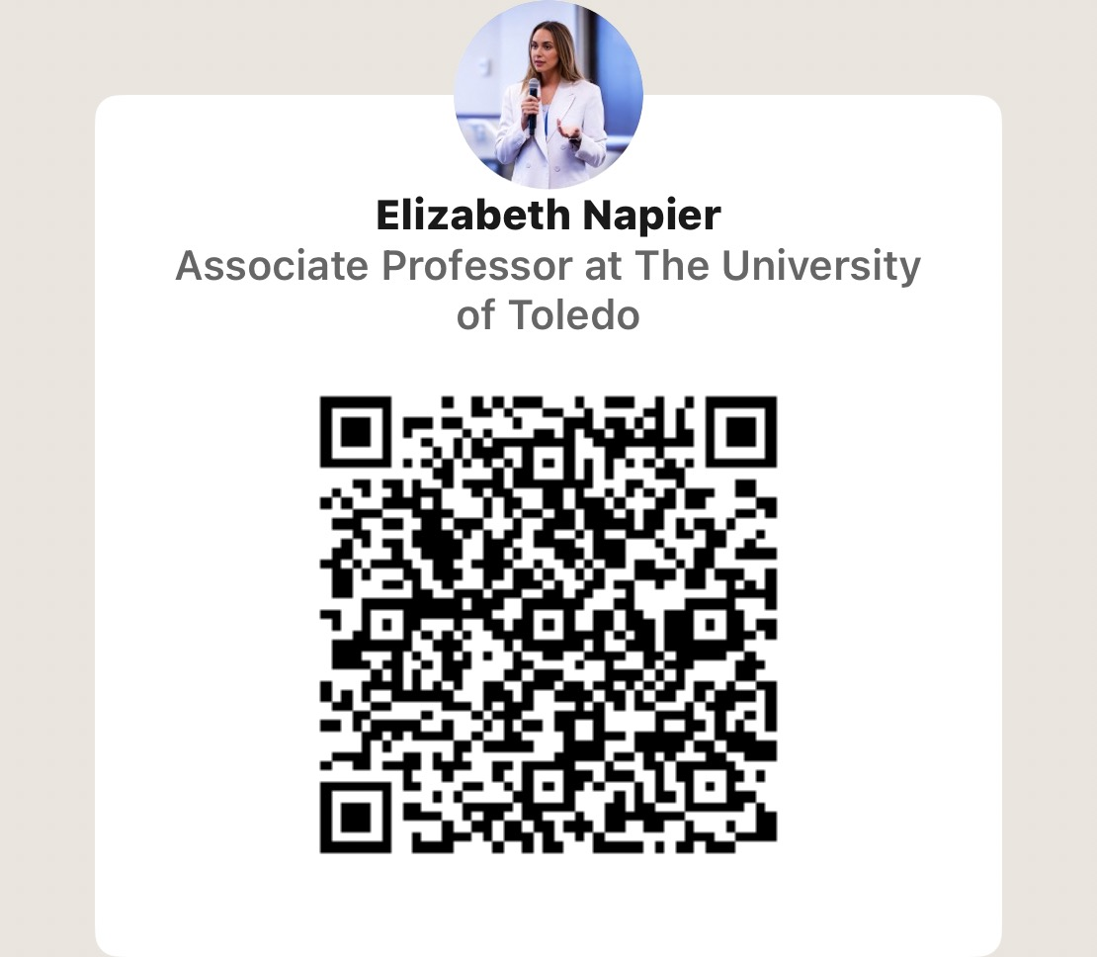
DR. ELIZABETH NAPIER
Associate Professor of Marketing and International Business
Neff College of Business and Innovation | University of Toledo
www.izzynapier.com | elizabeth.napier@utoledo.edu

Preparing for the Academic Job Interview
DOCTORAL CONSORTIUM | STUDENT HANDOUT
Use this guide to prepare for the job market and make deliberate choices in your first faculty role. Aim to communicate your contribution clearly, evaluate institutional fit, and establish habits that support a sustainable academic career.

Explain who you are as a scholar
Develop a clear research story. Prepare a two-minute introduction that explains your research question, why it matters, your contribution, and where your work goes next.
Show your independence. Be ready to explain your role in coauthored work and the research agenda you will pursue beyond the dissertation.
Personal perspective: My path from anthropology to international business and marketing connects my interest in people and culture with business questions. Identify the thread that connects your own experiences and research.

Practice the interview and research talk
Rehearse with different audiences. Invite peers and faculty outside your specialty. Practice answering questions about theory, methods, limitations, and future studies. Have a shorter version ready if time is reduced.
Respond thoughtfully. Listen fully, pause, and answer the question asked. Explain your choices, acknowledge limitations, and avoid becoming defensive.
Prepare for teaching questions. Bring concrete examples of learning goals, classroom activities, assessment, and how you adapt to different students. For a teaching demonstration, prioritize clarity over coverage.

Evaluate the opportunity
Ask questions that reveal how the department works in practice:
- How are research, teaching, and service evaluated for annual review and tenure?
- What teaching load, new course preparations, and delivery formats should I expect?
- What mentoring, research funding, data access, and conference support are available?
- What do junior faculty wish they had known before starting?

Discuss the full offer. Clarify salary, summer support, research resources, relocation, and the review timeline. Ask how prior work is counted, and document agreed terms.

Before your next interview - Prepare your research introduction, rehearse a timed talk, develop one teaching example, and write five questions about the department. Consider whether the location and community fit your life as well as your career.

Building Your First Years as Faculty
Establish priorities early and revisit them as your responsibilities grow. Expectations differ across institutions, so use your department’s written criteria and conversations with mentors to guide decisions.

Protect research time and maintain momentum
Know the expectations. Read review and tenure criteria during your first semester. Discuss them with your chair and mentors, and keep records of your work throughout the year.
Build a manageable pipeline. Protect recurring research time and track each project’s next action. Keep projects at different stages, with clear coauthor responsibilities and deadlines.
Personal perspective: Having progressed through tenure at Toledo, I encourage you to understand how your work will be evaluated before annual review season. Use those expectations to make intentional choices about your time.

Develop teaching you can sustain
Create clear structures. Use consistent course organization, assignment instructions, grading criteria, and communication policies. Improve courses incrementally rather than rebuilding everything each term.
Personal perspective: I teach undergraduate and MBA students across online and blended settings. Teaching the same concept to different audiences requires adaptation, and clear expectations help both students and faculty.

Choose service thoughtfully
Clarify the commitment. Ask about responsibilities, meeting frequency, workload, and term length before accepting a role. Seek guidance about appropriate service for your career stage.
Practice a useful response. “Thank you for considering me. Let me review my current commitments before I agree.”

Build support and protect your well being
Create a network of mentors. Seek different people for research feedback, teaching advice, and institutional guidance. Maintain relationships with doctoral peers and colleagues at other institutions.
Keep a life beyond work. Make space for relationships, movement, rest, and interests outside academia. A rejection or difficult semester is an experience to work through, not a measure of your worth.
Personal perspective: Alongside my faculty role, I am a yoga instructor and enjoy running and being outdoors. My interest in mindfulness and resilience informs how I think about sustaining an academic career.

Your first semester action plan
One research priority: _______________________________________________________
One person to ask for guidance: _______________________________________________
One boundary or routine to establish (something that bring you joy!): __________________________________________

